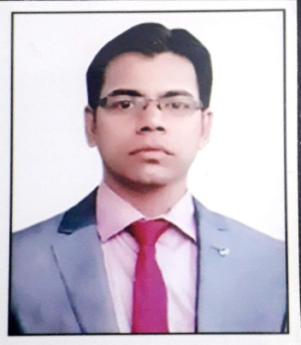
Self – Appraisal Report
General Information:
Name : Dr. Rishikesh Ranjan
Designation : Assistant Professor
Department of English
College of Commerce,Arts& Science, Patna
Address : Poorvi Yogipur, Kankarbagh, Patna
Mobile No. : 9891162726
Email ID : dr.rishikeshranjan@gmail.com

Educational Qualification:
Examination Board/University Passing Year Grade/Division
Matriculation BSEB,Patna 1999 1st
Intermediate BIEC,Patna 2001 1St
Graduation Delhi University 2004 2nd
Post-Gradution IGNOU,Delhi 2006 1St

Other Qualification:
Examination Board/University Passing Year
M.Phil CDLU,Haryana 2007
B.Ed Indraprastha University,Delhi 2008
NET UGC 2012
Ph.D Magadh University. Bodh Gaya 2015
Orientation Course UGC HRDC, Patna University, Patna 2017
FDP Of 12 Weeks NPTEL – AICTE 2020
Refresher Course UGC HRDC ,North Bengal University 2021
Refresher Course UGC HRDC, Osmania University, Hyderabad 2022

Academic Experiences:
- No. of Research paper published in National/International journal

S.N | Title of research Paper | Name of the Research  journal and ISSN | Year
1. | Sense of Belonging in the poetry of Nissim Ezekiel | Research Spectra-  ISSN -2394-9805 | Sept to Dec,2017
2. | A Comparative Analysis of Tragic Flaws in Shakespeare’s Macbeth and Hamlet | The Inward Eye : Patliputra Journal of English Studies ISSN : 2278-9162 | 2022-23

2. No. of Paper Presented / Attended in National Seminar/Conference

S.N | Topic of the Seminar | Title of Research Paper | Organizing Institution  and date
1. | Plurality of Religion,  Culture and language:  Comparative Perspectives | The Downcast and The  Downtrodden : A  Comparative study of M.R  Anand’s Untouchnable &  Arundhati Roy’s The god of  Small things | UGC Sponsored Seminar at PG Department of  English,Magadh University,  Bodh Gaya  Date:03rd and 04th Feb,  2018

2. | Gender Sensitization & women Empowerment | Feminist Study of Virginia woolf’s A Room of One’s  own | National Seminar at  Sachchidanand Sinha  College,Aurangabad  Date: 28 Nov, 2018
3. | 65th All India English Teachers’ Conference | Virginia Woolf’s skill of transforming personal experiences into art with special reference to her autobiographical novel To the Lighthouse | 65th All India English Teachers’ Conference held at Nav Nalanda Mahavihar, Nalanda,  24/11/2022 to 26/11/2022

Administrative Experiences:

- Deputed as Assistant Controller of Examinations at Patliputra University,Patna vide letter no.R/PPU/570/19 Dated 02/05/2019 and served there for three years from May, 2019 to May, 2022.

- Became the member of the Editorial Board of Peer reviewed Annual Research Journal “The Inward Eye” ISSN : 2278-9162 on 13/02/2021.

- At present 04 research scholars are pursuing Ph.D under my supervision.

(Dr. Rishikesh Ranjan)

